AFRICAN UNION
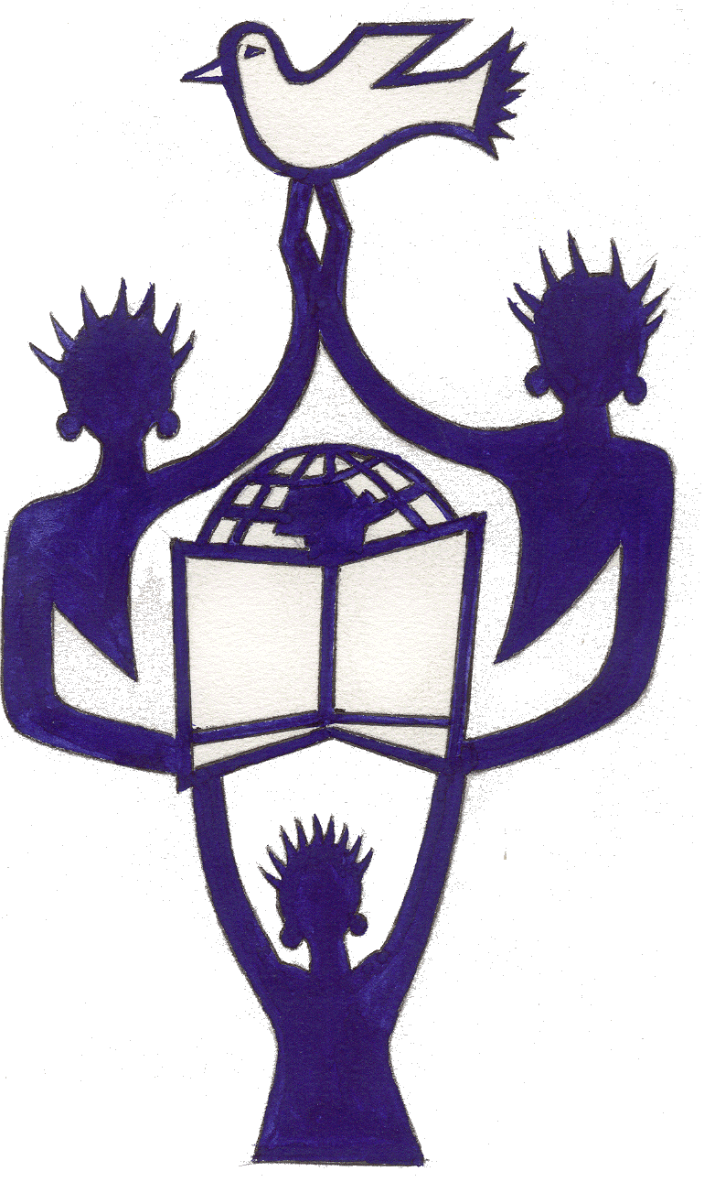
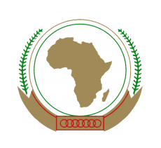
International Centre for Girls’ and Women’s Education in Africa
UNION AFRICAINE
Centre International pour l’Education des Filles et des Femmes en Afrique

3rd HIGH LEVEL DIALOGUE

BUILDING BLOCKS: TOWARDS IMPROVING EDUCATIONAL OUTCOMES
FOR GIRLS AND WOMEN INTERNALLY DISPLACED AND REFUGEES

CONCEPT NOTE

6th FEBRUARY 2018

- BACKGROUND AND CONTEXT

In its vision, the African Union clearly states its aspiration to a “Peaceful, Integrated and Prosperous Africa led by its peoples.” This has been reiterated in the Agenda 2063, in the Continental Education Strategy for Africa (CESA 16-25) and many other adopted policy frameworks. Unfortunately, more and more African countries are facing serious challenges of conflicts, war and poverty leading to low access to education, denial of theirs right to a minimum and basic services of learning opportunities, absence at school. More and more of these targets are found in fragile and vulnerable situations, unable to accomplish self and national development.
There has been on-going debates on the demographic dividend, corruption issues within the AU. It has been decided in 2019, to underline one of the most challenging concerns facing Africa and part of its populations, populations being forced to displace, to relocate or to become refugees. Girls and women are often the most affected in these situations, undermining their educational paths. It is thus urgent to find sustainable responses and interventions to support, build knowledge and skills, and to break the circle of violence of post conflict assistance.
In fact, conflict, persecution and violence have uprooted at least 3.2 million people in the first half of the year 2016, and low- and middle-income countries have played the greatest role in sheltering the world’s displaced (UNHCR, 2016). To make education a catalyst for economic growth and lasting peace, the right to access services for all segments of citizens should be recognized, respected and implemented. Absence of education can generate among others, more poverty, economic instability and more conflict. As more people are displaced, the global trend continues to rise, including Africa. Prospects for displaced people to return to their homes remain slim, whilst conflicts have intensified. Burundi, Central African Republic, the Democratic Republic of the Congo, Eritrea, Somalia, South Sudan and Sudan are places from where a big proportion of the population have been displaced. Even if statistics in Africa are not totally updated, it should be underlined that South Sudan’s refugee situation continues to grow and affect some of the world’s least developed countries, such as Sudan, Uganda, Kenya, DRC, CAR, and Ethiopia. Numbers have grown even further in the second half of 2016 Therefore, hosting countries are required to strategize in order to deliver services to the families. Young girls and women are the most affected targets.
Among social services delivery, education comes in as a fundamental human right, and appears to be one of the durable solutions for displaced young populations. Education can also be used as a prevention tool and protection strategy for victims, whilst building and strengthening capacity and skills.
- JUSTIFICATION
The African Union, through some of its departments, is required to scrutinize the thematic of the Year 2019, to work towards durable solutions for displaced populations and bring relevant proposals to member States. This will help them to address these raised issues through policies, frameworks, actions and strategies in view of supporting girls and women empowerment in vulnerable situations, refugees and displaced populations and their living conditions, the right and welfare of the child, women and girls struggling for survival in conflict and post-conflict contexts. Interventions such as teaching and learning in safe environments where possible, is an absolute must. These imply connecting to girls’ and women’s education policies, national education sector plans. Whilst struggling for safe & secure learning environments, there is also need to address multi-level contents and interventions to simultaneously remove all sorts of barriers such as gender based discriminations.
In the context of the third edition of the HLD IN 2019, AU/CIEFFA aims to address a fundamental human right: inclusive and holistic education, with a special attention to learning environments and to propose strategies to deliver quality education and skills, including STEM and TVET as learning subjects/contents and professional domains in order to support to social and economic development.

- OBJECTIVES
The 2019 HLD aims to address the following objectives, focusing on the theme of the year 2019 as set by the African union:
- Reflect on ways to bridge the gaps in schooling for girls facing conflict or forced displacement and the related challenges
- Improve understanding on scaling up quality education services, knowledge acquisition and technical skills development for the benefit of targeted girls / women and refugees based on national laws, policies and the right of displaced persons to education
- Propose actionable strategies for an accelerated and flexible education to meet diverse needs of the targets; facilitate contents through STEM and TVET learning opportunities whilst strengthening literacy and numeracy acquisition and other skills development
- Engage policy dialogue among different stakeholders to integrate displaced children and young people in mainstream national education systems
- Share experiences of best practices in targeted areas.

- Expected Outcomes
- Strategies to bridge school gaps through learning contents and back- to- school plan for displaced girls and women
- Established dialogue with member states on teaching/learning organization including contents and teacher training
- Actionable plan for promoting literacy, numeracy and subjects related to STEM and TVET in both knowledge and skills development
- Shared experiences through a common platform with all relevant stakeholders to engage and pursue dialogues for real changes in education systems at national levels

- Organisation of the Event
This event is under the auspices of H.E, Mr Moussa Faki Mahamat, Chairperson AUC; it is co-hosted by the African Union- International Centre for Girls and Women’s Education in Africa (AU/CIEFFA), the Department of Political affairs, AUC and the Permanent Mission of Norway to the African Union well as AU partners: UNESCO, UNICEF, Save the Children.

- Participants
This High level Dialogue will be addressed by the AU Chairperson or his Representative, the Minister of Foreign Affairs of Norway and the Minister of Education, Federal Republic of Ethiopia. Participants will comprise of Ministers of Education/Gender/Finance/Planning from selected African Union Member States, representatives of national governments, civil society groups, private sector/foundations, WGDD, AU Special Envoy for Women & Peace, AU-liaison Offices such as AMISOM, Vulnerable girls/women with success stories in similar context, Champions /Advocated for Girls and Women’s Education.

- METHODOLOGY/FORMAT
A report of findings related to displaced and refugees on educational outcomes will be presented. Selected high level participants as well as few officials from high level institutions and main education partners will be invited to share their views and comment on this research finding as well as propose strategies for improving educational outcomes for displaced and refugees.

- DURATION AND ORGANIZATION
The event will be a full day event, scheduled for the 6th February 2019, in Addis Ababa, Ethiopia.

